Experiment 5
Connecting Devices to a Wi-Fi Network

Lab 5 Objectives:
● Connecting Devices to a Wi-Fi Network, Implementing WPA2 Security, and Testing Connectivity
Prerequisites: The prerequisites of this lab are-
● Basic knowledge of networking concepts and wireless communication.
● Familiarity with Wi-Fi security protocols and encryption standards.
● Access to a router with WPA2 security and wireless-enabled devices.

Outcomes: By the end of this lab, students will be able to:
● Configure a Wi-Fi network and connect different devices securely.
● Implement WPA2 encryption for wireless security.
● Test network connectivity and troubleshoot common Wi-Fi issues.

Part 1: Understanding Wi-Fi Networks and Security
Step 1: Wi-Fi Fundamentals

Overview of Wi-Fi Standards (802.11a/b/g/n/ac/ax):
Wi-Fi has various standards that define speed, range, and frequency:
- 802.11a: Uses 5 GHz band, speeds up to 54 Mbps, less interference.
- 802.11b: Uses 2.4 GHz band, speeds up to 11 Mbps, more interference.
- 802.11g: Uses 2.4 GHz band, speeds up to 54 Mbps, backward compatible with 802.11b.
- 802.11n: Dual band (2.4 & 5 GHz), speeds up to 600 Mbps, uses MIMO technology.
- 802.11ac: Uses 5 GHz band, speeds up to several Gbps, faster and better range.
- 802.11ax (Wi-Fi 6): Latest standard with improved efficiency, speed, and capacity, supports both 2.4 & 5 GHz.
Understanding SSID, Channels, Frequency Bands (2.4 GHz vs 5 GHz):

- SSID (Service Set Identifier): The unique name of a Wi-Fi network.
- Channels: Wi-Fi operates on specific channels within frequency bands. The 2.4 GHz band has 1-11 channels, often overlapping; 5 GHz has more non-overlapping channels.
- Frequency Bands:
  - 2.4 GHz: Longer range but slower speeds and more interference.
  - 5 GHz: Faster speeds, less interference, but shorter range.
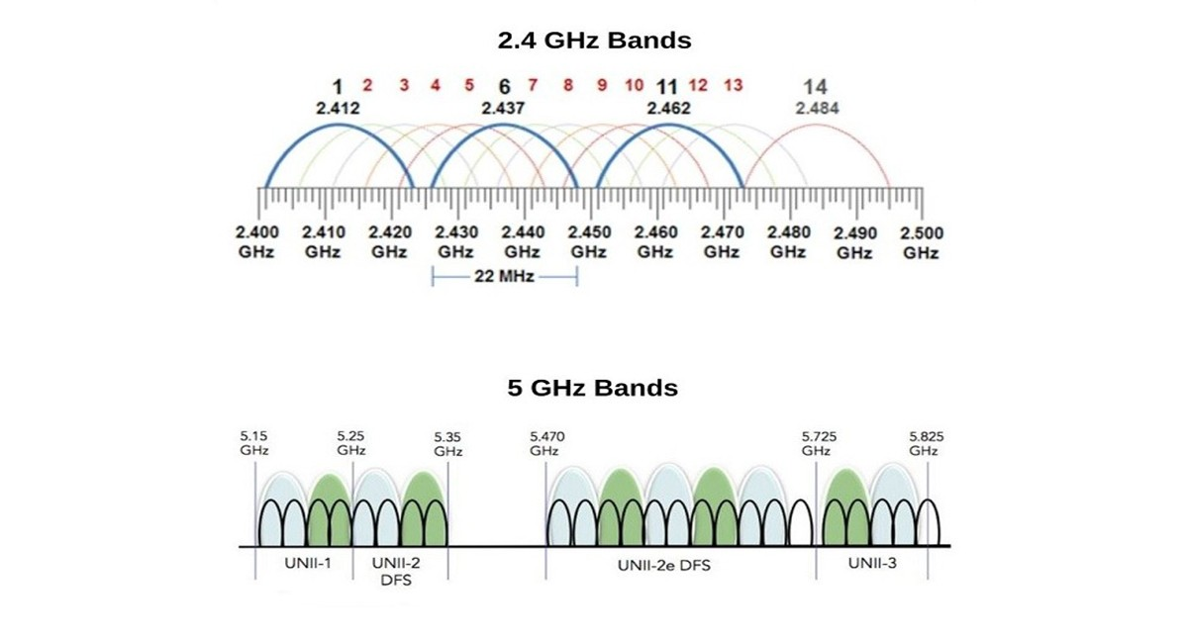

Step 2: Wi-Fi Security Basics
Explanation of WEP, WPA, WPA2, and WPA3 Security Protocols:
- WEP (Wired Equivalent Privacy): An outdated and insecure protocol.
- WPA (Wi-Fi Protected Access): Improved security over WEP but still vulnerable.
- WPA2: Currently the standard security protocol using AES encryption, highly secure.
- WPA3: The newest security standard with enhanced protection against attacks.
Importance of Encryption:
Encryption protects wireless data from unauthorized access and ensures privacy by encoding the data transmitted over the network.
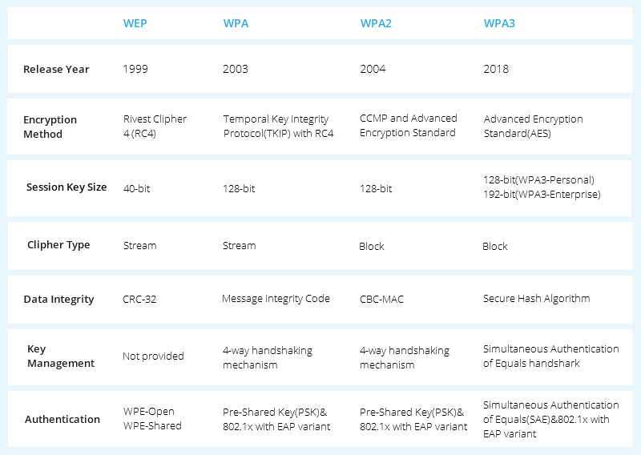

Part 2: Configuring and Securing a Wi-Fi Network
Step 1: Setting Up a Wi-Fi Network
- Access the router’s admin panel via a web browser by typing the router’s IP address (commonly 192.168.1.1 or 192.168.0.1).
- Login with the admin username and password.
- Set the SSID (network name).
- Select the network mode (such as 802.11n/ac/ax).
- Set a secure password for the Wi-Fi network.

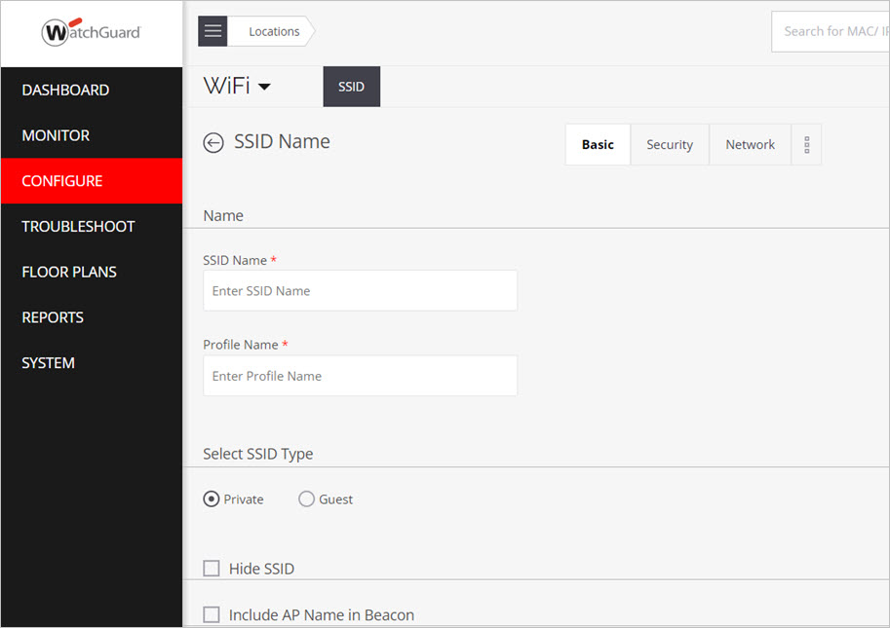

Step 2: Implementing WPA2 Security
- Enable WPA2-Personal security mode in router settings.
- Choose AES as the encryption method for strong security.
- Generate and set a strong passphrase containing uppercase, lowercase letters, numbers, and special characters.
- Save the settings.


Example: 123456780 Akdfudfni*@7990

Step 3: Connecting Devices to the Network
- On the laptop, smartphone, and IoT devices, open Wi-Fi settings.
- Select the SSID configured earlier.
- Enter the WPA2 password and connect.
- Verify devices are connected using WPA2 encryption.

Part 3: Testing and Analyzing Network Connectivity
Step 1: Checking Connectivity
- Use ping command in Command Prompt or Terminal to test internet connectivity, e.g.
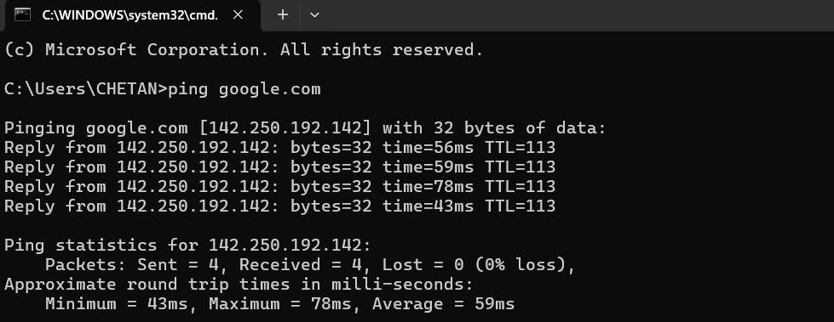

- Use tracert (Windows) or traceroute (Linux/macOS) to view the path data takes to reach a website:
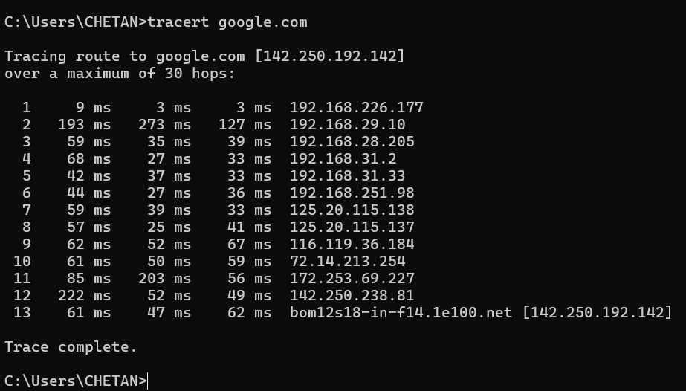

- Check both internet and local network connectivity.

